**Birth and evolution of the Paleocarnic Chain**

**in the Southern Alps: A review**

International Journal of Earth Sciences – in press

**Federico Pasquaré Mariotto1**, **Corrado Venturini2**

1Dept of Theoretical and Applied Sciences, University of Insubria, Via Mazzini 5, Varese 21100, Italy

2Dept of Biological, Geological and Environmental Sciences, Bologna University, Via Zamboni 67, Bologna 40126, Italy

**Abstract**

The present work is aimed at reviewing the state of the art of the studies centered on the pre-collisional and collisional, Variscan evolution of the eastern Southern Alps. The main focus is on the Carnic Alps, a geologically spectacular and extremely complex area, which has been a major subject of study for structural geologists, stratigraphers, and paleontologists for more than a century. After decades of field studies aimed at unveiling the birth and evolution of this belt, the tectonic and geodynamic interpretations proposed for almost a century by two different groups of authors remain substantially different. German-speaking authors, over the decades, have consistently proposed a scenario marked by a mature, Devonian passive margin, which later on evolved into an active Mississippian continental margin; the following collisional phase resulted in an accretionary wedge that, in its evolution, might be compared to those generated by Variscan events outside the Alpine domain. On the contrary, Italian authors have mainly put forward a pre-collisional setting dominated by wrench-fault tectonics, followed by the formation of a large, collisional thrust and fold belt, arc-shaped in plan view. We illustrate the results accomplished so far and discuss the interpretations formulated by the two different research schools; our review provides a chance to compare the different interpretations and, at the same time, prompts the need for new and targeted data collection in the area.

Keywords: Carnic Alps; Paleozoic; NE Italy; Variscan orogeny; basement; thrust-and-fold belt.

**Introduction**

The Carnic Alps, together with the neighboring Julian Alps (Friuli Venezia Giulia), geologically represent the eastern sector of the Southalpine domain. This, largely confined to the Italian and southernmost Austrian territories, is structurally delimited by the Periadriatic Line, separating it from the Eastern Alps.

The thick, Permian-Mesozoic succession of the Southern Alps (which, at some sites, also includes Pennsylvanian sediments), is formed by a thicker-than-10-km sedimentary pile, locally interleaved with magmatic products. The succession covers a Variscan basement, characterized by decreasing metamorphic grade from the NW to the SE **(Fig. 1)**.

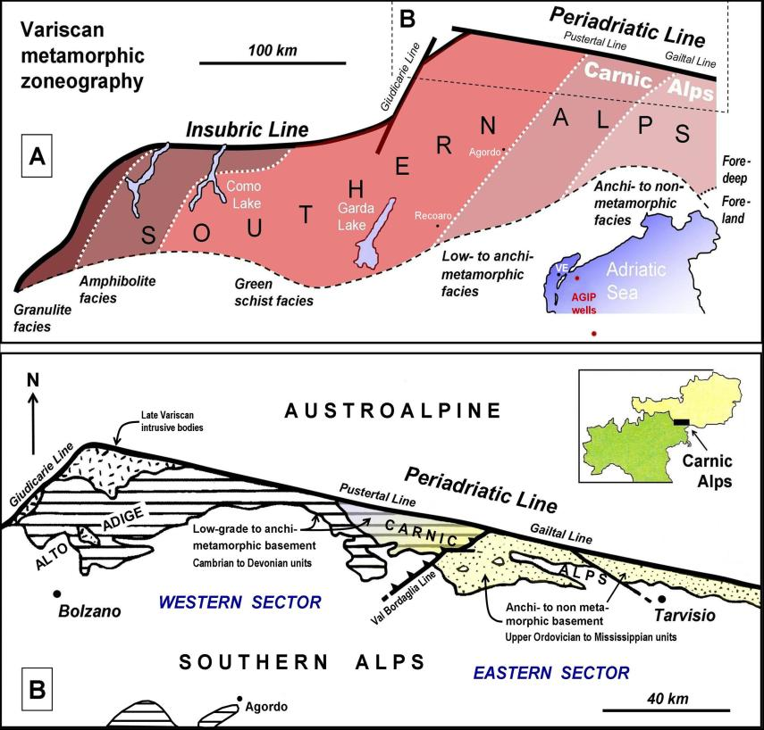

***Fig. 1*** *-* ***A.*** *Zoneography of the Variscan metamorphism in the Southalpine basement of the Southern Alps. The orientation refers to present-day North. Modified after Vai and Cocozza (1986).* ***B.*** *Location of the Carnic belt, subdivided into the western, low-grade metamorphic basement, and the eastern anchimetamorphic and non-metamorphic sequence. VE = Venice.*

On the scale of the whole Alpine belt, the Carnic Chain is part of the southern portion of a doubly vergent belt, generated by the right-lateral, transpressive activity of the Periadriatic Line in Miocene times (Neubauer and Genser 2018). At the core of the Carnic Alps lies the Variscan basement, which, although strongly deformed, is marked by anchimetamorphic and non-metamorphic conditions (Sassi et al. 1974; Vai and Cocozza 1986; Rantitsch 1997; Brime et al. 2008).

This feature, unique for the entire Italian peninsula, enables documenting in an almost continuous fashion, from the Late Ordovician to the Quaternary, the occurrence of marine and continental sedimentary paleo-environments, interleaved with periodic, significant magmatic events. Ordovician-Carboniferous deposits found in the Carnic Alps have recorded, in a spectacular fashion, the build-up of two orogenic belts, the Variscan and the Alpine ones, as well as the complex relations of several deformation systems, which have interfered with each other over time and space.

The original Variscan structure can be reconstructed by analyzing unconformities (Venturini et al. 1983; Venturini 1990a) and by subtracting from the Variscan tectonic setting the effects caused by the Alpine orogeny. These are recorded in the late- and post-Variscan successions from Pennsylvanian to Cenozoic times (Venturini et al. 1982, 2009; Venturini 1990a,b, 1991b; Menegazzi et al. 1991; Läufer1996; Hubich et al. 2000).

The present work is aimed at illustrating the progressive structural changes that affected the easternmost Southern Alps (Friulian sector) during Variscan times, and showing their tectonic architecture, kinematics, and geodynamic evolution.

**The Alpine tectonic overprint**

The Variscan structural evolution of the chain cannot be fully understood unless the Alpine tectonic setting and kinematics are illustrated, with particular regard to the deformations affecting Pennsylvanian and Permo-Mesozoic successions. The Alpine deformational architecture of the Carnic range is the result of a multi-phase orogenesis, which has been active since Eocene times and is still under way. The complex geometries of the orogenic belt are tightly linked to the anti-clockwise rotation of the direction of the maximum stress, compatible with the changes in the convergence trajectory of Africa relative to Europe (Mazzoli and Helman 1994).

The Alpine tectonic and kinematic analysis of the Carnic belt was based on the detailed geological mapping of the inner portion of the chain (Selli 1963b,c; Venturini 1990b; Menegazzi *et al*. 1991; Hubich et al. 2000; Venturini et al. 2001-2002) across more than 1,000 square kilometers. Here, the deformation can be ascribed to both the meso- and neoalpine phase. The latter, in particular, had a major impact on the structure of the belt, as well as on the Variscan substrate, though in a non-homogeneous fashion **(Figs 2** and **3)**.

In the eastern Southern Alps, the mesoalpine (Eocene) compression direction, as well as the early neoalpine (Chattian-Burdigalian) one, range between ENE-WSW and NNE-SSW (Castellarin et al. 1998; Caputo et al. 2010). Overall, they produced the so-called dinaric orientations, represented by sets of thrust and fold structures with an average NW-SE trend.

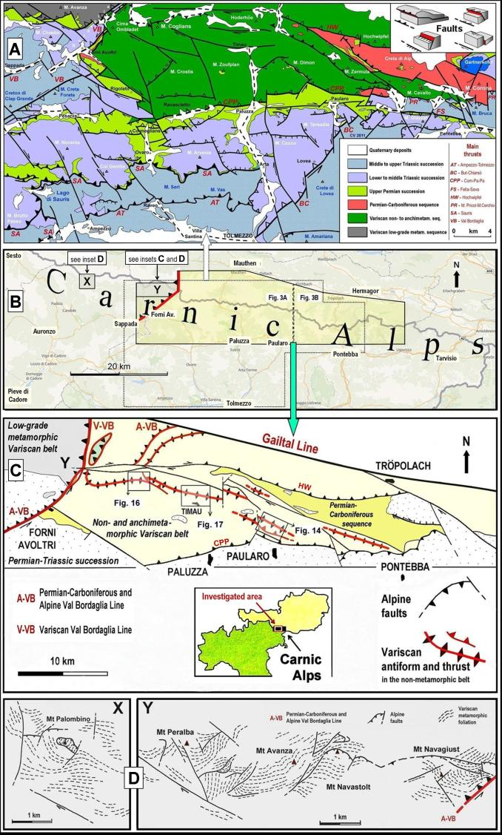

***Fig. 2*** *- Simplified tectonic map of the Carnic Alps. Modified after Muscio and Venturini (2012). In the eastern, non- and anchimetamorphic sector, large Variscan structures are shown, which are still recognizable to this day (central figure modified after Venturini 1991b); in the western, low-grade metamorphic sector (insets X e Y, modified after Menegazzi et al. 1991), the pattern of the Variscan foliation, affected by Alpine events, can be observed.*

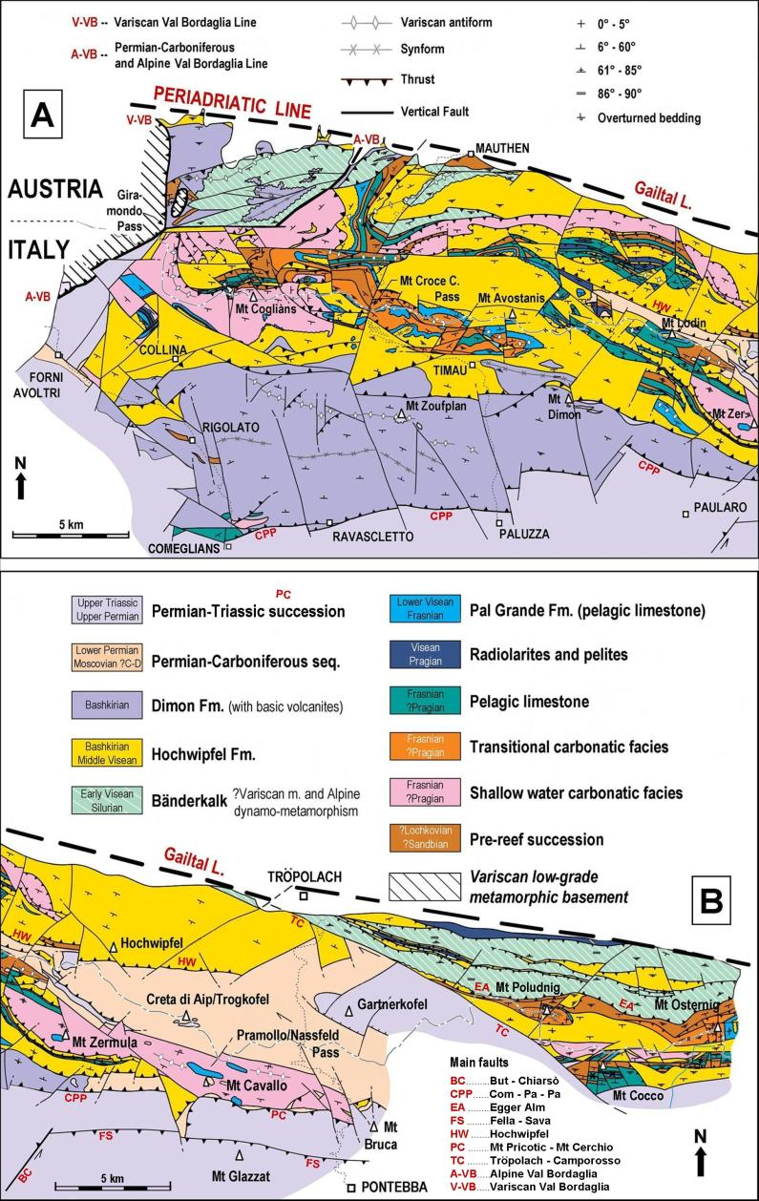

***Fig. 3*** *- Geological map of the eastern, non- and anchimetamorphic sector of the Carnic Alps. Data have been assembled and synthesized from the original, 1:25.000 scale cartography (Venturini et al. 2001-2002) and reported in Brime et al. (2009).* ***A.*** *Area between Forni Avoltri (Val Bordaglia) and Paularo (Mt Zermula);* ***B.*** *Area between Paularo (Mt Zermula) and Ugovizza (Mt Osternig).*

Mesoalpine deformations are pervasive in the Julian Southern Alps, whereas towards the north they become less intense and almost disappear in the Alpine Carnic areas. The thick, Permo-Carboniferous and Permo-Triassic successions of the Carnic Alps, lying unconformably on the ancient Paleozoic substrate, were affected exclusively by early neo-Alpine deformation, focused in limited areas (Venturini et al. 2001-2002; 2009); here, a common deformative style can be noted, represented by thin-skinned, embricated tectonic slices.

Three neoalpine phases generated tight systems of folds and thrusts, which can be grouped in a number of sets, respectively trending WNW-ESE, E-W and NE-SW; among such sets there are several, complicated interferences and reactivations (Venturini 1990a; Discenza and Venturini 2003; Läufer 1996; Venturini et al. 2009).

As highlighted above, the earlier neoalpine deformation phases affected a few, limited areas, and can be attributed to a NNE-SSW directed compression that took place in Late Oligocene-Early Miocene times (Caputo et al. 2010; Ponton 2010). Later structures, oriented E-W and produced by a N-S directed maximum stress, date back to the Mid- and Late Miocene (Ponton 2010).

Their development played a major role in shaping the present-day tectonic pattern of the entire Carnic area, generating a tight, S-vergent thrust and fold belt. Locally, there is evidence of back-verging and reactivation of syn-sedimentary faults (NE-SW and NW-SE) inherited from the Permo-Carboniferous and, most notably, Mesozoic evolution (Venturini 1991a).

The latest, neo-Alpine deformation phase was produced by a NW-SE directed compression, active from Late Miocene to Pliocene times (Caputo 1996; Caputo et al. 2010). In Bartel et al. (2014) there is a comparison among the paleostress data collected by various authors. The effects of this stage are observed in scattered areas of the Carnic belt in Friuli, whereby new deformations were produced (Venturini and Carulli 2003; Venturini et al. 2009), often through the transcurrent reactivation of previous, neo-alpine faults. To this stage, some major tectonic inversion events along syn-sedimentary faults are ascribed. These had already played a transcurrent role during the previous, N-S directed compressional phase (Discenza and Venturini 2003).

In the time period between the Variscan orogeny and the Alpine tectonic phases, there was a significant, late-Variscan phase, dating back to the Pennsylvanian-Early Permian and generated by a right-lateral, transtensional setting, documented at a wider scale (Arthaud and Matte 1977).

During the multi-phase alpine shortening, the systems of late- and post-Variscan, syn-sedimentary faults, still perfectly recognizable across the whole area (Venturini, 1983; Venturini et al. 2001-2002), were affected by reactivation processes, with tectonic inversions and well-documented strike-slip displacements (Venturini 1990a, 1990b, Venturini et al., 2009).

The paleo-Periadriatic Line was interpreted as belonging to this set of late-Variscan structures (Cassinis et al., 1997). The tectonic complexity increases greatly, as far as the Variscan basement is concerned; this is covered, through a sharp unconformity, by the Permo-Carboniferous or the Permo-Triassic succession (**Fig. 4**, Venturini 1990a, 1991b; Venturini et al. 2001-2002; Vai et al. 2002).

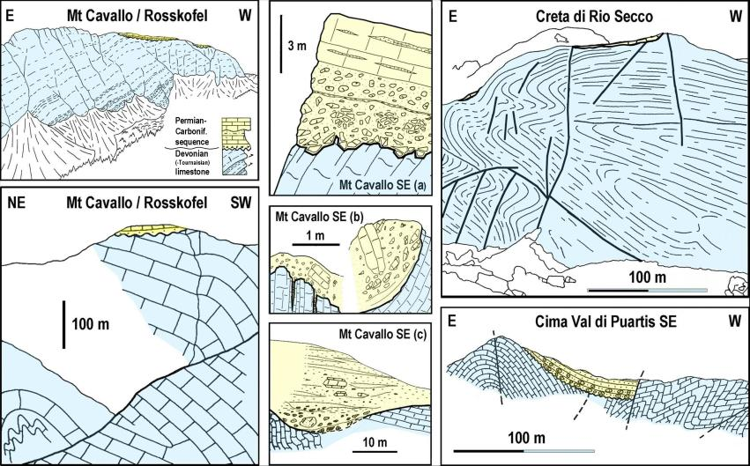

***Fig. 4*** *- Angular unconformities between the non-metamorphic succession of the Variscan, Carnic Belt, and the Permo-Carboniferous cover. Pramollo/Nassfeld Basin. Modified after Venturini et al. (1983) and Venturini (1990a).*

Meso- and macrostructural analyses, based on the recognition of the different tectonic styles and angular unconformities, enabled distinguishing Variscan deformations from Alpine ones. More specifically, after palinspastically back-tilting the unconformable successions, (assuming their originally horizontal attitude) so as to document the pre-tilting Variscan bedding, the attitudes of Variscan deposits are in the N75°-155°E range, with a maximum frequency around the N120°E trend (Venturini 1990a).

This is in agreement with substantial macrotectonic evidence in areas where the cover was removed due to Quaternary erosive processes (Venturini et al. 2009), (see Fig. 3). In the Carnic Alps, more than 90% of Variscan units are composed of limestones (of Devonian age) and alternating arenites and pelites (of Carboniferous age).

The Carboniferous successions, due to their fragility, were heavily affected by Alpine tectonics, which had the effect of masking the Variscan deformation heritage almost everywhere. On the contrary, the calcareous, inner portions that formed the large Variscan folds **(Fig. 5)** were capable of resisting the effects of Alpine tectonics.

Here, limited tilting, partial torsions and strike-slip displacements are observed. These rock units are located along the watershed that represents the Italian-Austrian border.

Outcrops are documented, where the main, non- and anchimetamorphic (eastern sector) Variscan nucleus is observed; this can be explained in terms of the ramp rupture within a major ramp-flat structure, the Sauris Fault (Venturini et al. 2009).

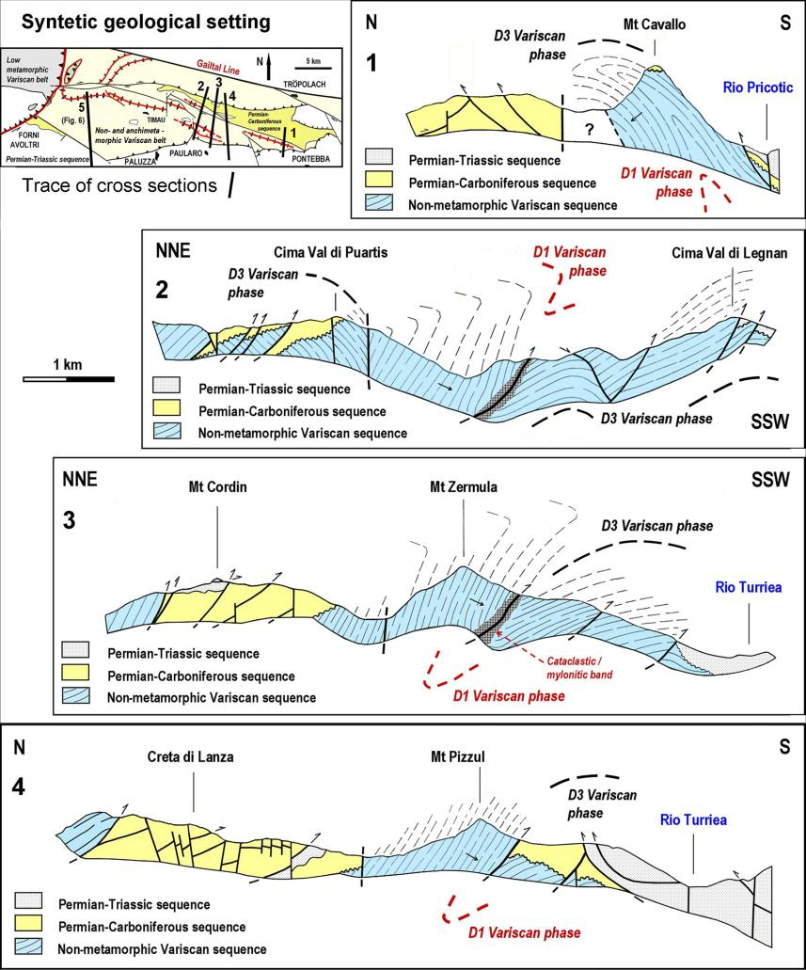

***Fig. 5*** *- Geological cross-sections across the eastern sector of the Carnic Alps. Several angular unconformities can be observed, as well as two, coaxial generations of Variscan folds, successively affected by Alpine tectonics. Modified after Venturini (1990b).*

The vertical uplift due to this steep-dipping thrust, the Comeglians-Paluzza-Paularo (Com-Pa-Pa) Fault, is about 1.5 km **(Fig. 6)**. Both faults were activated during the N-S directed compression, dating back to the mid- to late Miocene.

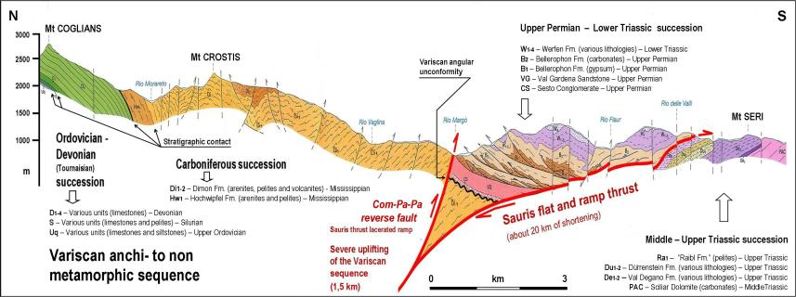

***Fig. 6*** *- Geological cross-section showing the reactivation of the Sauris Fault ramp (Venturini et al. 2009). It is responsible for the Alpine exhumation (late Miocene) of the main Variscan core of the Carnic Alps. Modified after Venturini et al. (2001-2002).*

**The Variscan Paleocarnic Chain**

The vast, Central European Variscan orogeny, produced by the collision between Gondwana and Laurussia, is represented by a double vergent belt, which was formed over a time interval of more than 100 million years, from the Devonian to the Carboniferous (Matte 1998). The Variscan core of the Carnic Alps is part of the belt’s southern outer edge.

The overall vergence of its macrostructures is towards the southern quadrants in present-day coordinates. The remnants of the Paleocarnic Variscan belt extend as a continuous E-W elongated strip between NE-Italy and Austria. The basement crops out from Monte Croce of Comelico Pass to Coccau Pass (Tarvisio) across a total length of 120 km; the width of the outcropping segment is from 5 to 15 km.

Towards the north, the belt is bordered by the eastern segment of the Periadriatic Line, known as Gailtal Line, which separates the Southalpine domain from the Austroalpine one. Some authors claim that this structure was already active as a major late-Variscan master-fault (Cassinis et al. 1997; Vai 2003), based on the geometric relations between fault systems and related subsidence-affected basins (Venturini 1983) and the location of the Periadriatic Line in the framework of the major, right-lateral shear zone between southern Europe and northern Africa (Arthaud and Matte 1977).

At places and towards the south, the belt is unconformably covered by Upper Paleozoic and Triassic successions. The successions belonging to the Southalpine domain, including the basement and its cover, belonged to the African plate as early as the Paleozoic (Manzoni et al. 1989; Matte 1986). At the end of the Variscan paroxysm (Pennsylvanian, Moscovian), these successions were situated at latitude 4°N (Manzoni et al. 1989), according to paleomagnetic data related to the Early Permian in the Southern Alps (Muttoni et al. 1996).

From the end of the Variscan orogeny to present times, the whole, central-eastern Southalpine segment (Dolomites, Prealpi Vicentine and Carnia) was subject to a 40° (or greater), anti-clockwise rotation (Vandenberg and Zijderveld 1982; Manzoni et al. 1989; Bard 1997; Márton et al. 2003; Muttoni et al. 2013).

Along an E-W trend, the Paleocarnic belt can be subdivided into two sectors (see Fig. 1): the westernmost one, with its low-grade metamorphic basement, and the anchimetamorphic and non-metamorphic sector to the east (Selli 1963a; Sassi et al. 1995; Hubich et al. 2000).

The latter is represented by the Paleocarnic Chain’s well-known, extremely fossiliferous sedimentary succession, as well as by magmatic, effusive products; the whole sedimentary-magmatic pile dates back from the Late Ordovician to the Carboniferous (Bashkirian) (Corradini and Sutter, 2015).

Low-grade metamorphics cropping out in the western sector were formed between Mid-Ordovician and Mid-Devonian times (Hinderer 1992; Hubich et al. 1993). The two sectors of the belt are in contact along the Bordaglia tectonic boundary, extending between Friuli and Veneto.

This is a system of brittle structures, very close to each other, trending from NNE-SSW to NE-SW. Such tectonic boundary is made rather complex by the occurrence of several closely-spaced, subparallel faults, derived from the Variscan and Alpine orogenies.

For a long time, such faults have been generically referred to as a unique structure, the Val Bordaglia fault. Within the Val Bordaglia tectonic boundary, Poli et al. (1996) and Läufer et al. (2001) identify a structure of Variscan age, trending about NNE-SSW, with tectonic displacement towards the east.

Brime et al. (2008) differentiate between the latter and a tight system of NE-SW striking faults, interpreted as a late-Variscan (Permo-Carboniferous), syn-sedimentary tectonic heritage, which was subsequently reactivated several times during the Neoalpine phase (Miocene-Pliocene).

**The low-grade metamorphic basement**

West of the Val Bordaglia thrust, the Paleocarnic Chain is made of a low-grade basement, observed also in the easternmost outcrops of Alto Adige, Agordo and Recoaro (see Fig. 1). The age of the rocks involved in the metamorphic processes ranges from Mid-Ordovician to Mid-Devonian times (from the Late Cambrian in Agordo and Recoaro, Vecoli et al. 2008).

Within the basement, Del Moro et al. (1980) identify two metamorphic peaks, respectively dating back to 350 and 310-320 Ma (Hammerschmidt and Stöckhert1987). As regards the later metamorphic event, Ring and Richter (1994) assume a burial depth of 18-24 km, a closure interval from 310-320 Ma and an exhumation around 290 Ma with an exhumation rate of 0.2- 0.5 mm/year.

In the western sector of the Carnic Alps, Hubich et al. (1993) document a set of lineations, which share a common ESE-oriented trend, and which belong to a number of macrofolds whose axes tend to slightly rotate, in a westward direction, from an N120°E trend to an E-W one. Poli et al. (1996), in the Agordo area, recognize two blastic phases (greenschist facies).

During the first (350 Ma), there was a displacement towards SE during a collision dating back to the Late Devonian-Visean, with underthrusting of the southern margin towards the north. During the second, taking place within a thickened lithosphere, NW-SE and N-S trending, meso- and macroscale folds were generated.

**The anchimetamorphic and non-metamorphic sequence**

East of the Val Bordaglia thrust, the Paleocarnic Chain shows anchimetamorphic and diagenetic conditions. This segment is regarded as the outermost deformation front of the southern Variscan belt, directed towards the south (see Fig. 1).

This is attested by the location of a non-metamorphosed intrusive body, Late Ordovician/Silurian in age (AGIP 1972), revealed by drillings performed by AGIP in the northern Adriatic Sea, just east of Venice.

Its pre-collisional, paleoenvironmental evolution (Late Ordovician-Carboniferous) has been elucidated by sedimentological and stratigraphic research published over the last four decades (Cantelli et al. 1982; Schönlaub 1985; Hubich et al. 1993, Venturini et al. 2009; Corradini et al. 2012; Corradini et al. 2016).

The anchimetamorphic and non-metamorphic Variscan succession of the eastern Carnic Alps (Corradini and Suttner 2015) is between 2 and 4 km thick.

The units belonging to the Variscan succession have been described by several authors over the years, as detailed below. Ordovician and Silurian deposits have maximum thicknesses of a few hundreds of meters, whereas Devonian (up to 1.5 km thick) and Carboniferous deposits (up to 2 km thick) are the most prevalent units.

In regard to Ordovician deposits, the oldest found in the Carnic Alps are of Mid-Ordovician age, and are exposed west of the Val Bordaglia thrust (Corradini et al. 2017).

Silurian deposits are irregularly spread across the Carnic Chain, with an overall thickness not exceeding 60 m (Corradini et al. 2017). Their lithological, sedimentological and paleontological features are described in a number of papers (Jaeger 1975; Jaeger and Schönlaub 1977, 1980, 1994; Schönlaub 1997; Brett et al. 2009; Corradini et al. 2010, 2015; Histon 2012).

Devonian (up to Tournaisian) rocks are here represented by prevalent stratified limestones deposited in lagoon, forereef, basin paleoenvironments and by massive bio-constructed limestones (Kreutzer 1990, 1992; Schönlaub 1992; Kreutzer et al. 1997; Suttner 2007; Corriga et al. 2012).

The extremely rich fossil content derived from these paleoenvironments is described in papers by Kreutzer (1990, 1992); Kreutzer et al. (1997); Schönlaub (1992) and Rantitsch (1992). In the early Frasnian, a diffuse tectonic drowning/sinking (see below for details) caused the extinction of the reefs.

The following Carboniferous units (Visean-Bashkirian), as specified in detail in the following chapter, range from terrigenous arenites to pelites with diffuse turbiditic features, the so-called “Hercynian Flysch” (Auctorum). Within such units, acidic and basic volcanic remnants are interbedded **(Fig. 7)**.

The different rheological characteristics of the two lithofacies, the carbonatic and siliciclastic ones, must have played a key role in preserving the Variscan structural and deformational inheritance. In this regard, several Variscan macro-folds are still recognizable owing to the presence of massive and folded limestones at their core, which were capable of resisting the effects of the Alpine compressive phases.

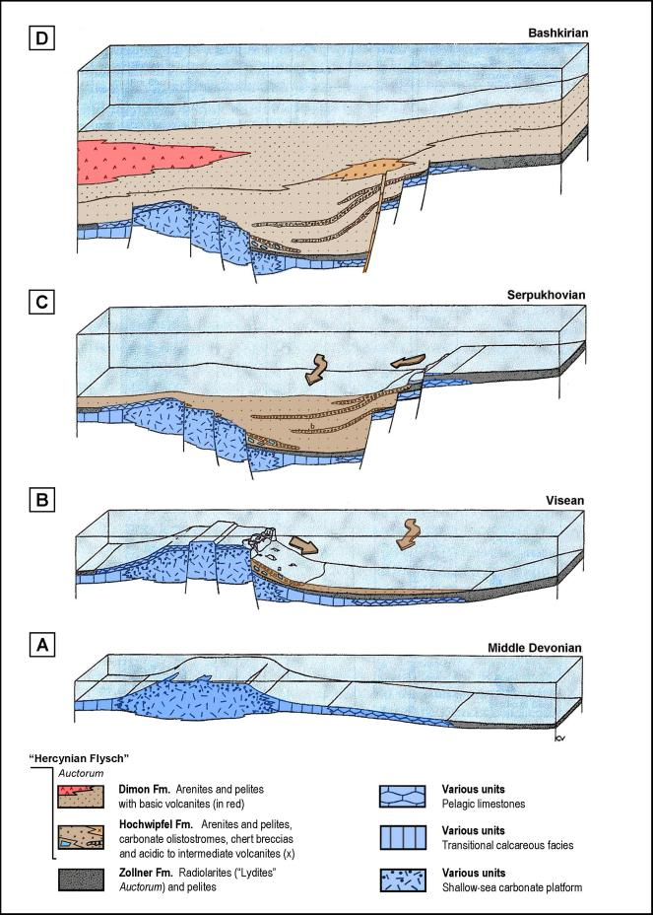

***Fig. 7*** *- Simplified evolution of the Carnic basin from the Mid-Devonian to Carboniferous times. Modified after Spalletta et al. (1982b).*

**The pre-collisional phase**

In regard to the pre-collisional evolution of the Paleozoic succession of the Carnic Alps, as briefly mentioned above, the establishment of a reef depositional environment was followed by a rapid drowning, due to eustatic processes and, more locally, by tectonic motions.

These were produced by syn-sedimentary faults of Late Devonian-Mississippian age (Spalletta et al. 1980, 1982a; Läufer et al. 1993).

The tectonic subsidence was accompanied by pelagic conditions, documented by Schönlaub (1969), Schönlaub and Kreutzer (1993) and Perri and Spalletta (1998). In the Visean-Bashkirian, the thick turbiditic, quartz-rich sediments (Hochwipfel Fm.) of the “Hercynian Flysch” (Auctorum) began to be transported into the deepening through.

These deposits are considered by all authors as the product of the erosion of the Variscan belt, which was advancing from the NW and/or N. The deep marine through that hosted the “Hercynian Flysch” (Auctorum) was located on a thin shelf of the N-African crustal block (Engel et al. 1981; Stampfli 1996).

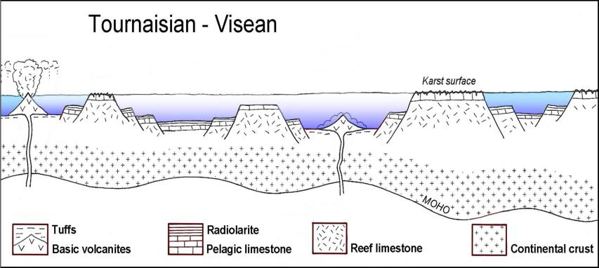

***Fig. 8*** *- Stratigraphic setting in the Carnic sector during the Lower Carboniferous. The hypothesized contemporaneity between the deep-sea, basic effusive products (pillow lavas) and the subaerial karst processes affecting Devonian-Dinantian limestones is highlighted. Modified after Läufer et al. (1993).*

According to Italian authors **(Fig. 8)**, the subsidence culminated in the emission of about 200-m-thick basic alkaline volcanic products (pillow lavas), enriched in Ti (Rossi and Vai 1986; Germani 2007).

This volcanic activity was interpreted as resulting from rifting processes affecting a thinned continental crust, which, in turn, was triggered by transcurrent motions (Vai 1976). The submarine effusive episode, accompanied by abundant pelites and quartz-feldspathic arenites, is believed to have closed the Variscan cycle (Vai 1974; Venturini et al. 2009; Corradini and Suttner 2015).

The interruption was caused by the migration towards the southof the orogenetic front, which reached the Carnic area in the late Bashkirian, as documented by all the authors.

A different scenario is proposed by most of German-speaking authors (Fig. 9), according to whom the submarine, basic alkaline volcanic activity took place earlier than the deposition of the “Hercynian Flysch” (Auctorum) turbidites (Läufer et al. 1993, 2001; Läufer 1996).

In their opinion, an extensional phase such as the one that led to the outpouring of the submarine volcanic products, cannot be reconciled with a compressive phase like the Variscan one, testified to by the widespread presence of flyschoid deposits.

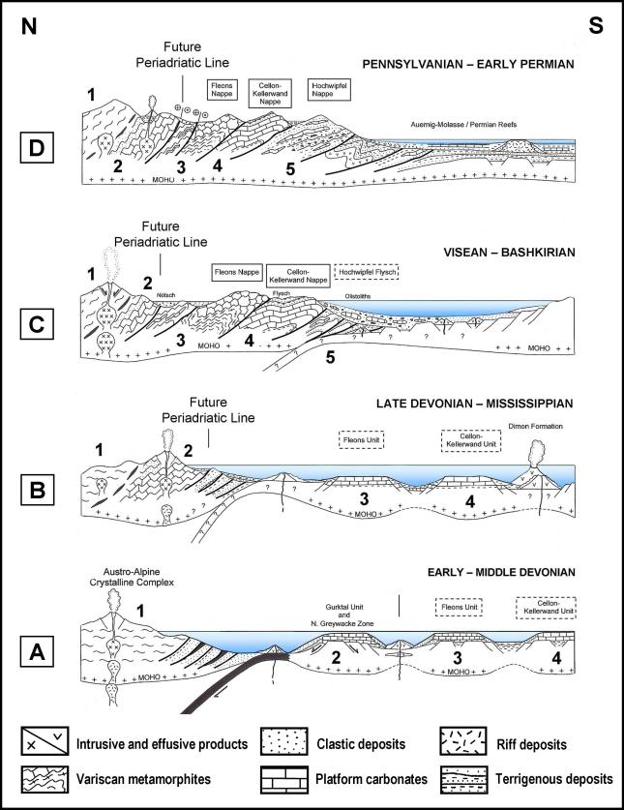

***Fig. 9*** *- Stratigraphic and geodynamic evolution of the Carnic Alps during Early Devonian-Early Permian times, according to Läufer et al. (2001). The numbers (1 to 5) indicate the locations of the different paleogeographic successions involved in the formation of the chain.*

Based on the above, as documented in Läufer et al. (2001, and references therein), a different age is attributed to the submarine volcanic activity **(Fig. 9)**, which is claimed to have taken place in the Mississippian (Läufer et al. 1993). According to this viewpoint, the volcanic activity must have followed the extensional phase (rifting) and preceded the deposition of the turbidites.

The geodynamic framework that characterized the Carnic area in Carboniferous times, as outlined above, represents a classic example of a frontal convergence: The advancement of the Variscan orogenetic front from the N (and/or NW) interrupted the extensional phase (Late Devonian-Mississippian); the latter was replaced by a compressional tectonic phase, attested by the diffusion of siliciclastic turbidites.

It is worth noting that this interpretation is at odds with the stratigraphic data derived from the detailed geological mapping of the overall Carnic area, which seem to prove the opposite (Selli 1963b,c; Venturini et al. 2001-2002).

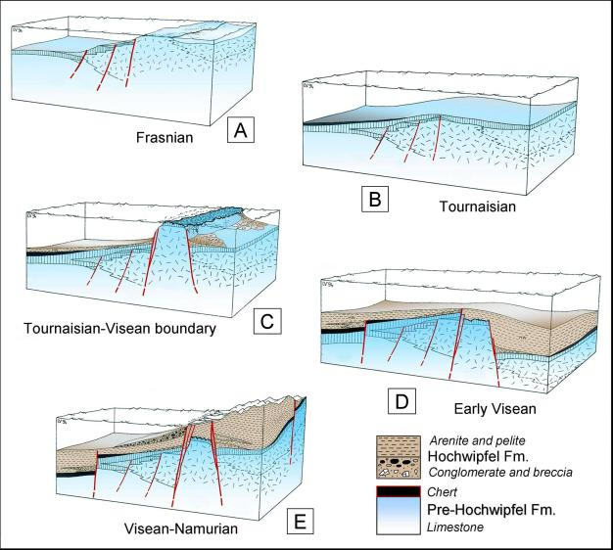

***Fig. 10*** *- Late Devonian - Mississippian evolution of the Paleocarnic domain. Syn-sedimentary faulting caused both the tectonic drowning and the uplifting of individual blocks. The emerged blocks were subjected to karst processes and erosion, which supplied the Hochwipfel basin with local immature deposits, interbedded with mature sediments. Modified after Spalletta and Venturini (1994).*

It is likely that the pre-collisional evolution of the eastern Paleocarnic segmentwas marked by the episodic occurrence of shallow-sea and deltaic environments, facing deep sea environments. There are some major sedimentological-stratigraphic clues that enable to confirm this paleogeographic scenario. They are, in order:

*a)* Karst surfaces that affect part of the Devonian-Tournaisian carbonatic succession (Schönlaub et al. 1991). They were produced at the Tournaisian-Visean boundary **(Fig. 10C)** and were concentrated on limited structural highs (Spalletta and Venturini 1988; Läufer et al. 1993), which fed the turbiditic sedimentation later on **(Fig. 10D)**.

*b)* Ruditic horizons with a lot of well-rounded cherts and arenitic clasts, up to 35 cm in size (Spalletta and Venturini 1988). They are interbedded with turbiditic deposits of the “Hercynian Flysch” (Auctorum) and are often associated with clustered plant remains (Ameron et al. 1984) and reworked, fossiliferous, shallow-water limestones of Visean age, up to 20 cm in size (Flügel and Schönlaub 1990, Venturini et al. 2009) **(Fig. 10E)**.

*c)* Widespread and thick breccias and micro-breccias with predominant radiolarite clasts. They are concentrated in the lower portion of the “Hercynian Flysch” (Auctorum) (Spalletta and Venturini 1988), **(Fig. 10A,C)** and are interpreted as thin rudites, fed by the sliding of material along submarine, active fault planes (Spalletta et al. 1980).

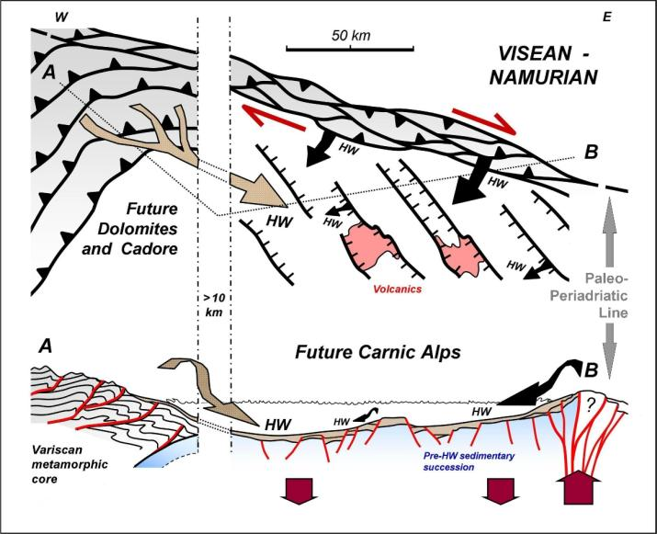

***Fig. 11*** *- Speculative geodynamic evolution of the Carnic Alps during Mississippian times. It is worth noting the presence of the subduction-related belt in the western area, as well as the flexural basin to the E, affected by transpressive/transtensive activity. Modified after Spalletta and Venturini (1994).*

According to Italian authors, all the above evidence calls for a strike-slip tectonic scenario, active within a large shear-zone (Castellarin and Vai 1981; Spalletta and Venturini 1988). The master fault is believed to be represented by the eastern paleo-Periadriatic (Gailtal) Line (Spalletta and Venturini 1995).

In this Mississippian geodynamic framework, the right-lateral shear zone along the eastern paleo-Periadriatic Line (Cassinis et al. 1997) **(Fig. 11)** is distally connected (through an active subduction, directed towards NW) to the deformation front in progressive advancement towards the Carnic sector (Spalletta and Venturini 1994). It is likely that further north, a number of parallel systems of wrench faults were active in the same way as is suggested here.

Sonntag et al. (1997), Mader and Neubauer (2004), Mader et al. (2007) and Neubauer et al. (2007), based on the study of detrital white micas from Mississippian syn-orogenic sandstones, propose a classic frontal convergence setting, marked by a compressional accretionary wedge and a related flexural basin associated with a peripheral bulge, whose occurrence might be confirmed by shallow-water deposits.

**The collisional phase**

The Variscan deformative setting of the Paleocarnic Chain was also interpreted in a substantially different way by the two groups of respectively German-speaking and Italian authors. Gaertner (1931) describes the Paleocarnic Chain as a tectonic nappe structure.This interpretation was reaffirmed over the years by other German-speaking authors, some of whom (Heritsch 1936) recognize as many as 10 tectonic nappes, with associated roots, in an area that is only 10 km across; the nappes were transported from about S to N and superimposed on each other.

Over time, German-speaking authors have constantly put forward the interpretation centered on tectonic nappes; nevertheless, they have continued discussing the number and vergence of the tectonic nappes. Hubich et al. (2000) and Läufer et al. (2001) recognize, in the non-metamorphic Variscan core of the Carnic Alps (eastern sector), two sedimentary and/or anchimetamorphic sequences.

They distinguish the sequences based on their presumed age, which they regard as slightly diachronic, and based on their lithologies: The basic volcanites belong only to the older sequence.The two sequences were eventually superimposed onto each other, during the Variscan orogeny, forming two tectonic nappes: the Cellon-Kellerwand and Hochwipfel nappes **(Fig. 12)**.

According to German authors (Läufer et al. 1993; Kullmann and Loeschke, 1994), the emplacement of the nappes was accompanied by a set of olistholites and olistostromes, the occurrence of which led to the interpretation of the depositional environment of the Hochwipfel Fm. as a wildflysch basin.

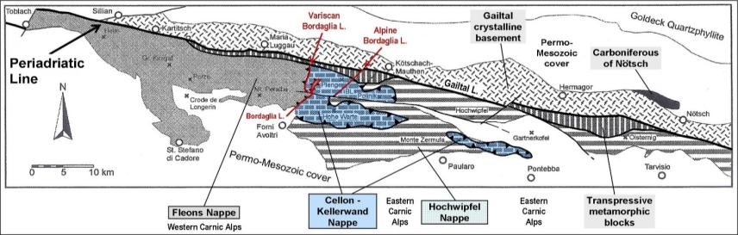

***Fig. 12*** *- Tectonic framework of the Carnic Alps according to Hubich et al. (2000) and Läufer et al. (2001). Three Variscan tectonic units, namely Fleons, Cellon-Kellerwand, and Hochwipfel, are highlighted. The transpressive bands are marked by a metamorphic imprint of the Alpine age (probably superimposed on the Variscan metamorphism). They are interpreted as an effect of the Alpine transpressive kinematics associated with the Periadriatic Line. Modified after Hubich et al. (2000).*

Italian authors have always opposed the interpretation centered on the tectonic nappes: The very same olistholites and olistostromes, concentrated in the lower part of the Hochwipfel Fm. and limited in terms of volume and surface distribution, have been interpreted as the result of sedimentary processes associated with sin-sedimentary tectonics initiated across the Tournaisian-Visean boundary (see Fig. 10C).

The occurrence of a wildflysch basin is not regarded, by Italian authors, as realistically possible. In the Variscan core of the eastern Carnic Alps, Vinassa de Regny and Gortani (1911) and Gortani (1926, 1957) identify a deformative style characterized by macro-antiform folds, which they name “ellipsoids”.

At the beginning of the second half of the 20th century, the structural studies focused on the Paleocarnic sector were integrated by new geological maps (Selli 1963b,c; Vai 1963). Data derived from those studies still appeared to oppose the interpretation based on the tectonic nappes.

However, in the works from the 1960s, the presence of “ellipsoids” is no longer mentioned. According to Selli (1963a) and Vai (1963, 1976), the dominant Variscan deformative style in the eastern Paleocarnic Chain is a tight system of “imbricated tectonic slices” marked by a vergence towards SW. The thickness of the tectonic slices ranges, on average, from a few tens of meters to more than a kilometer.

In addition to the above, with the purpose of explaining the complicated pattern of Variscan deformation, Selli (1963a) makes reference to unspecified gravitational displacements, active during the orogenetic paroxysms. Among Italian authors, Cassinis et al. (1974) cast doubts on the above interpretations, highlighting the poor degree of preservation and recognition of ancient structures in the Variscan Carnic Chain, strongly deformed by a polyphasic Alpine orogeny.

This would be confirmed by the widespread presence of rock units dominated by pelites, the “Hercynian Flysch” (Auctorum), which can be easily deformed, as well as by the presence of giant overturned folds. Such folds, regarded by Cassinis et al. (1974) as “hard-to-interpret Hercynian heritage”, may have induced Selli (1963a) to hypothesize the presence of a gravitational tectonic component. Vai (1974) establishes a connection between the “Carnic” phase of the Variscan orogeny to the “Leonian” one in the Asturian Chain.

The Italian authors agree on its short duration, between 5 and 10 million years at most. German-speaking authors (Fenninger et al. 1976) propose a much shorter duration. The end of the Variscan deformations was interpreted to correspond to the late Moscovian stage of the chronostratigraphic marine scale. This interpretation is made possible by the occurrence of the first late-Variscan, fossiliferous deposits, that unconformably cover the Variscan succession (Pasini 1963).

However, all Italian and German-speaking authors agree on the final deformative effect of the Variscan orogeny: the displacement along the Val Bordaglia thrust of the western low-grade metamorphic core, transported towards ESE (or SE) over the eastern, anchimetamorphic and non-metamorphic portion of the Paleocarnic Chain (Selli 1963a,b; Sassi et al. 1995; Poli et al. 1996; Läufer 1996; Läufer et al. 2001; Brime et al. 2008).

This is attested by Pennsylvanian and/or Upper Permian, non-metamorphic deposits, that unconformably cover the whole, western and eastern Variscan belt. Based on detailed surveys (Venturini 1990b), which were subsequently integrated and expanded (Venturini et al. 2001-2002), the wealth of field evidence previously reported by the authors (macro-antiforms, “ellipsoids”, “imbricated tectonic slices” and huge successions folded and overturned) was integrated into a single, tectonic-kinematic model (Venturini 1990a; Menegazzi et al. 1991; Sassi et al. 1995).

Such model is centered on the features, as well as the mutual interferences, between the Variscan macro-structures (folds and faults), which are found both in the eastern (Venturini 1990b) and in the western (Menegazzi et al. 1991; Hubich et al. 1993) cores.

**Tectonic and deformative styles**

In regard to the sector E of Val Bordaglia thrust, field-based studies enabled to observe the overlapping, onto the same rock volume (Upper Ordovician-Carboniferous), of three different tectonic styles **(Fig. 13)** (Venturini 1990a). All the structures experienced a coaxial development: They trend N120°E and are mainly directed towards SSW (backward-directed vergence towards NNE is locally observed).

The structures attest to decreasing crustal depths over time, with exhumation lasting between 5 and 8 million years and an exhumation rate estimated to be around 2 mm/year. During the first stage of the “Carnic” phase (*sensu* Vai 1976), a number of large asymmetric folds were generated (stage D1). The only structure among these, which is still recognizable within the approximately 15-km-wide Variscan core, is that of Mt Zermùla **(Fig. 14)**.

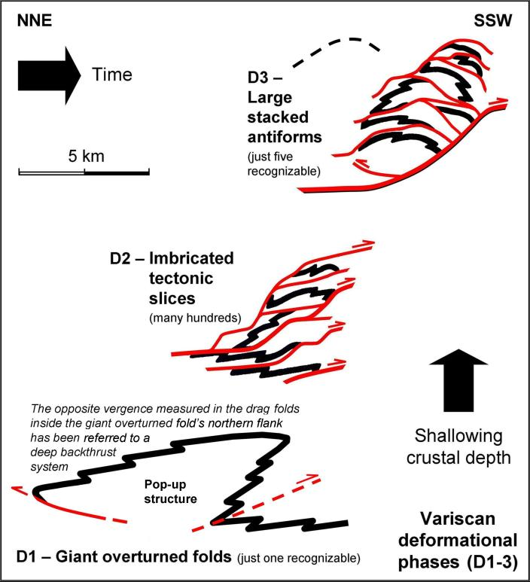

***Fig. 13 -*** *Variscan deformation superimposed on the units of the anchimetamorphic and non-metamorphic Carnic belt (eastern sector). The age of the deformative processes is Bashkirian-Moscovian. All the structures share a common vergence towards SSW. The final deformation stage (D3-large stacked antiforms) is well recognizable also in the low-grade metamorphic portion (western sector). Modified after Venturini (1990a).*

The mountain, mostly made of Devonian, calcareous facies, has been interpreted as being the massive, overturned limb of the huge fold. Its overall thickness is around 2 km.

The large asymmetric fold is verging towards SSW and, during the same event, was detached along its hinge line and thrust onto the “Hercynian Flysch” (Auctorum) (see Fig. 14).

Right in correspondence of the hinge line fault, Läufer et al. (2001) identify the contact between the two hypothesized Variscan tectonic nappes of the eastern, non-metamorphic sector (see Fig. 12).

This early deformation stage may account for the presence of the vast reverse sector of Mt Zermùla, which was hard to interpret for a long time, in the framework of the palinspastic reconstruction of the Variscan core (Castellarin and Vai 1981; Cassinis et al. 1974).

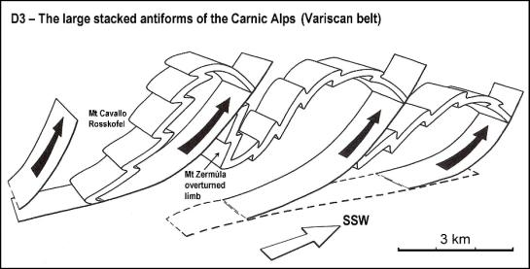

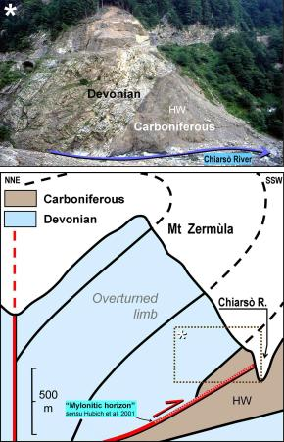

***Fig. 14*** *- Eastern sector of the Carnic belt, with an anchimetamorphic and non-metamporphic basement. The photograph shows the structure of the core of a giant overturned fold (faulted in correspondence of the hinge line), dating back to the first Variscan deformation stage (D1). HW = Hochwifpel Fm.*

***Fig. 15*** *- The stacked, antiform folds and associated thrusts (D3) are the most representative Variscan deformational pattern in the Carnic Alps (see Fig. 12). In the sketch, the intermediate deformations (D2), represented by the “imbricated tectonic slices”, were removed for the sake of clarity. Modified after Venturini (1990a).*

The second stage (D2), coaxial to the first, should be responsible for a dense system of shallow-dipping faults that dissect the previous structure, forming tectonic slices with different size and thickness (see Fig. 13). The latter correspond to the “imbricated tectonic slices” (Selli 1963a), considered for many decades the only deformation pattern in the sector E of the Val Bordaglia thrust.

A third compressional stage, coaxial with both previous ones, eventually generated a system of large thrusts, associated with a system of large stacked antiforms, whose vergence is towards SSW as well (see Fig. 13).

In the non-metamorphic portion of the belt, several large stacked antiforms and related thrusts have been identified **(Fig. 15)**.

They correspond to the “ellipsoids” from Vinassa de Regny and Gortani (1911) and Gortani (1957) and affect the previous deformation systems (first and second stages). This deformative style is also recognizable in the low-grade metamorphic units of the western sector (Menegazzi et al. 1991).

In places where the Variscan macro-antiforms involve calcareous lithologies, they are still recognizable despite the overlapping of the polyphasic Alpine deformations.

Such Alpine effects, in such cases, are represented by partial rotations and/or changes in the dip of the folds’ axes (Fig. 16), and by the fragile dissection by vertical faults **(Fig. 17)**. On the contrary, the arenites and pelites belonging to the flyschoid succession, with a lower resistance to shear stresses, were affected by later, major deformation, which had the effect of making the Variscan folding events poorly recognizable.

At the end of this third stage (D3) the orientation of all Variscan structural axes attained a constant trend (N120°E) in both sectors separated by the Val Bordaglia thrust. The common vergence of most of the structures is therefore towards SSW, with only local backward-directed structures.

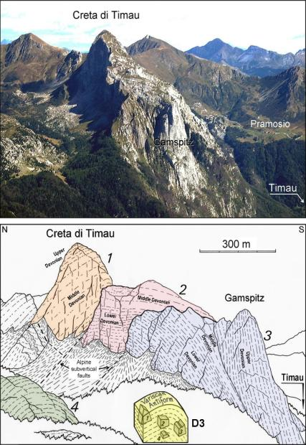

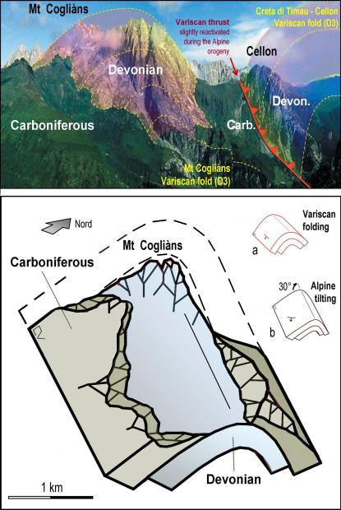

***Fig. 16*** *- Large Variscan antiform fold (D3) at M. Cogliàns. The Devonian core crops out owing to Quaternary erosion processes. On the right-hand side of the photograph, it is possible to observe a lateral portion of the “Creta di Timau” antiform fold (see Fig. 17) thrust over the former fold. Structural axes strike N120°E. The axis of the M. Cogliàns antiform fold was affected, during the Alpine orogeny, by an about 30°-tilting towards ESE, which resulted in a modification of the attitude of the fold’s limbs.*

***Fig. 17*** *- The Creta di Timau Variscan antiform fold (D3). During the Alpine orogeny, the fold was dissected by a number of vertical faults that displaced the various blocks (1-4), thus modifying the original geometry. Modified after Venturini (2006).*

The shortening of the Variscan Carnic belt corresponds to 20% of the pre-collisional length (Castellarin and Vai 1981; Venturini 1990a). The maximum horizontal stress in the Carnic Alps was directed in a NNE-SSW direction **(Fig. 18A)**: This is regarded to be part of a fan-shaped distribution whose main vector is about NNW-SSE.

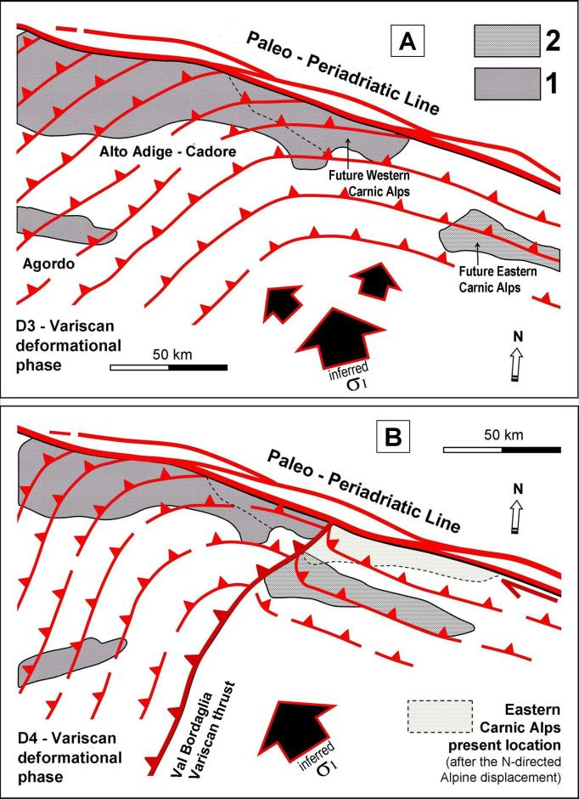

***Fig. 18*** *- Variscan structural settings of the central-eastern Southalpine sector during early Moscovian times (upper sketch). 1) Low-grade Variscan metamorphic basement; 2) Non- to anchimetamorphic Variscan basement.* ***A.*** *This is the phase (D3) in which, during the collisional convergence and an interruption in the strike-slip activity of the paleo-Periadriatic Line (between the Bashkirian and the Moscovian), the stacked antiforms were generated.* ***B.*** *In the final phase (D4) of the Variscan orogeny in the Carnic Alps, the right-lateral reactivation of the easternmost segment of the paleo-Periadriatic Line was likely responsible for the underthrusting of the non-metamorphic sector beneath the low-grade metamorphic one, along the Val Bordaglia thrust, thus enabling its complete exhumation. Modified after Venturini and Spalletta (1998).*

To account for this kinematic framework, it is necessary to hypothesize a prolonged locking of the strike-slip, eastern paleo-Periadriatic Line (between the Bashkirian and the Moscovian), which can be interpreted as the main cause of the fan-shaped distribution of stresses.

A fourth deformative stage (D4) finally locked the fold and thrust belt, thus enabling the western low-grade metamorphic portion to overlap the anchimetamorphic and non-metamorphic eastern portion along the Val Bordaglia thrust (Fig. 18B), (Selli 1963c; Sassi et al. 1995; Poli et al. 1996; Venturini and Spalletta 1998; Brime et al. 2008).

An important evidence, shared by all authors, is the fact that this brittle structure (NNE-SSW) is almost orthogonal to the Variscan deformative structural axis (WNW-ESE). In the Carnic area, this scenario has been interpreted in terms of the reactivation of right-lateral activity along the eastern paleo-Periadriatic Line, at the time when the Variscan orogeny was almost over (Bellot et al. 2002, **Fig. 19**), at about 310 Ma.

The strike-slip, right-lateral role of this important paleo-structure was then followed by the major, late-Variscan dextral transcurrent motions active between Laurussia and Gondwana during the Pennsylvanian and the Early Permian (Arthaud and Matte 1977; Cassinis et al. 1997).

In regard to the latter point, according to Vai et al. (1984), the orogenic mechanism responsible for the formation of the Variscan Carnic chain seem to have essentially been of the strike-slip type; there was never an actual collision (which took place elsewhere), replaced by oblique, multiple collisions (Vai et al. 1984).

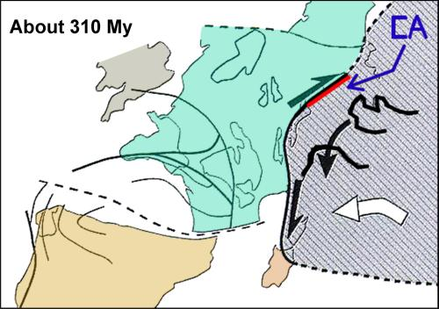

***Fig. 19 -*** *Reconstruction of plate tectonic movements in Central Europe during the “Namurian right-lateral shearing”, active in the Bashkirian-Gzhelian time interval. CA: future Carnic Alps. Modified after Bellot et al. (2002).*

The authors concluded that the structure along which this long-lived, right-lateral transcurrence took place, is the paleo-Peridriatic Line, almost correspondent with the present-day structure. In addition to the above, Poli et al. (1996) postulate that the tectonic overthrusting of the metamorphic terrain (western sector of the chain) over the non-metamorphic one (eastern sector) was guided by major transcurrent structures.

The Paleozoic rock units that, at present, are in contact with the two sides of the Val Bordaglia thrust, reached their current position owing to the Alpine reactivation of the dense system of the Val Bordaglia faults. Their new, left-lateral, strike-slip kinematics role was activated during the main N-S directed, Neoalpine compressional phase (Mid-Late Miocene) (Venturini 1990a,b; Läufer 1996; Caputo et al. 2010).

On the contrary, according to German-speaking authors (Läufer et al. 2001, see Fig. 9C), the Variscan Val Bordaglia thrust has to be regarded as one of the brittle contacts that were formed already during Visean times, simultaneously with the development of the Carnic belt tectonic nappes (the Cellon-Kellerwand nappe and the Hochwipfel nappe, according to Läufer et al. 2001).

In their interpretation, the migration of the orogenic front seems to have occurred almost perpendicularly to the paleo-Periadriatic Line (Gailtal Line). However, the same paleo-structure, also activated in Visean times, is regarded by the same authors as part of the sequence of Variscan thrusts, which were moving towards the Carnic area (see Fig. 9D).

Once the Variscan paroxysm was over, across a wide, South-European area, there were generalized, right-lateral, strike-slip movements between Laurussia and Gondwana (Muttoni et al. 1996). The paleo-Periadriatic Line was reactivated, once again with a right-lateral kinematics.

In the Carnic areas, this tectonic setting led to the development of localized pull-apart basins (Pramollo-Nassfeld basin), marked by a strong, syn-sedimentary tectonic activity (Venturini 1991b, and references therein).

**Conclusions**

The pre-collisional and collisional Variscan settings that characterized the Carnic Alps (NE of Italy) have been interpreted, for more than a century, in rather different ways by two schools of thought, the Italian one and the German one. The authors belonging to each school of thought put forward substantially different interpretations over time. In regard to the Variscan core of the Carnic Alps, located at the southeastern European margin of the Variscan belt, German-speaking authors propose a classical geodynamic model (see Fig. 9) characterized by a mature, passive margin (Late Devonian-Tournaisian), which later on evolved into an active continental margin (Visean-Serpukhovian).

According to this interpretation, the collisional phase, which ended in the Moscovian (Westphalian C), produced an accretionary wedge that, in its evolution, might be compared with those generated by Variscan events outside the Alpine domain (i.e. Montagne Noire). According to this interpretation, the Val Bordaglia thrust was responsible for the final shortening of the belt, with the overlapping – which the authors assumed to be already active during Visean times – of the western, low-grade metamorphic portion, onto the anchimetamorphic and non-metamorphic eastern one. The Val Bordaglia structure, together with another two, major thrusts, defined a system of tectonic nappes.

As opposed to the above, Italian authors postulate, for the Carnic sector, a pre-collisional setting dominated by a wrench-fault tectonics. Such setting, at the local scale, was regulated by the mainly transcurrent activity of a master fault, identified with the paleo-Periadriatic Line (eastern segment). During the whole pre-collisional phase (Tournaisian-early Bashkirian), its right-lateral, strike-slip activity must have influenced the transtensive evolution of the Carnic basin, favoring also the development of a continental rift.

The sectors subjected to extensional motions were affected by the deposition of siliciclastic turbiditic products derived from the Variscan orogenetic front, which was moving from distal areas such as South Tyrol and Austria, due to a subduction towards NW (see Fig. 11). The “Carnic” phase of the Variscan orogeny (5-10 Ma in duration, between the Bashkirian and the Moscovian) appears to have been active during a prolonged interruption in the transcurrent movements of the eastern paleo-Periadriatic Line. The main effect ascribed to this phase was the formation of a large thrust and fold belt, arc-shaped in plan view (see Figs 1 and 18).

The related Carnic structural axes, trending WNW-ESE, affected both the eastern, anchimetamorphic and non-metamorphic and portion, as well as the western, low-grade one, the latter in progressive exhumation. During the “Carnic” orogenetic phase, the right-lateral reactivation of the eastern paleo-Periadriatic Line eventually caused the overthrusting of the western low-grade metamorphic portion onto the anchimetamorphic and non-metamorphic eastern one (see Fig. 18), with a tectonic advancement towards ESE (or SE), as shared by all authors from both groups.

The post-orogenetic, Permian (and locally Carboniferous, late Moscovian), non-metamorphic cover, which lies unconformably on top of the entire Variscan belt, testify to the overthrusting of the two portions of the chain during, and at the end, of the Variscan event.

In conclusion, in spite of the apparent incompatibility of the two interpretations proposed by the two groups of authors that have worked in the Carnic Alps so far, it is worth underscoring a common geodynamic setting, shared by both German-speaking and Italian authors; this is represented the overall Variscan subduction towards NW (and/or N) and the coeval advancement of the orogenetic front in the opposite direction, i.e. towards the Carnic area.

The different opinions put forward by the two research groups emerge on the local scale: While German-speaking authors propose a classic convergence context, Italian authors highlight also the role played by transpressive activity along some segments of the paleo-Periadriatic Line. This activity might have been able to affect the dynamic evolution of the flexural basin and the typology and distribution of its terrigenous and volcanic deposits.

**Acknowledgments**

We gratefully acknowledge Franz Neubauer and Andrea Zanchi for their insightful comments, which enabled us to substantially improve the quality of our work. We wish to thank Claudia Spalletta for critically reading the manuscript and providing suggestions. Monica Pondrelly is acknowledged for redrawing and simplifying the map of the Carnic Alps.

**References**

AGIP (1972) Acque dolci sotterranee. Grafica Palombi, Roma.

Ameron van HWJ, Flajs G, Hunger G (1984) Die 'Flora' der Marinelli Hütte (Mittleres Visé) aus dem Hochwipfel-Flysch der Karnischen Alpen (Italien). Med. Rijks Geol. Dienst 37:1-41.

Arthaud F, Matte P (1977) Late Paleozoic strike-slip faulting in Southern Europe and Northen Africa: Result of a lateral shear zone between the Appalachians and the Urals. Geol. Soc. Am. Bull. 88:1305-1320.

Bard JP (1997) Démembrement anté-mésozoique de la chaine varisique d’Europe occidentale et d’Afrique du Nord: role essentiel des grands décrochements transpressifs dextres accompagnant la rotation-traslation horaire de l’Afrique durant le Stéphanien. Les Comptes Rendus de l’Académie des Sciences, Paris 324:693-704.

Bartel EM, Neubauer F, Heberer B, Genser J (2014) States of paleostress north and south of the Periadriatic fault: Comparison of the Drau Range and the Friuli Southalpine wedge. Tectonophysics 637: 305-327.

Bellot J.-P, Bronner G, Laverne C (2002) Transcurrent strain partitioning along a suture zone in the Maures massif (France): result of eastern indenter tectonics in European Variscides? In: Catalàn JM, Hatcher Jr RD, Arenas R, Garcìa FD (eds) The building of the late Paleozoic basement, Variscan-Appalachian Dynamics. Geol. Soc. Spec. Pap. 364:223-238. Brett C, Ferretti A, Histon K, Schönlaub HP (2009) Silurian Sequence Stratigraphy of the Carnic Alps, Austria. Palaoeogoegr. Palaeocl. 279: 1-28.

Brime C, Perri MC, Pondrelli M, Spalletta C, Venturini C (2008) Polyphase metamorphism in the eastern Carnic Alps (N Italy-S Austria): Clay minerals and Conodont Colour Alteration Index Evidence. Int. J. Earth Sci. 97:1213-1229.

Cantelli C, Spalletta C, Vai GB, Venturini C (1982) Sommersione della piattaforma e rifting devono-dinantiano e namuriano nella geologia del Passo di Monte Croce Carnico. In: Castellarin A, Vai GB (eds) Guida alla geologia del Sudalpino centro-orientale. Soc. Geol. Ital. Guide Geol. Reg. 9:293-303.

Caputo R (1996) The polyphase tectonics of eastern Dolomites, Italy. Mem. Sci. Geol. Padova, 48: 93-106.

Caputo R, Poli ME, Zanferrari A (2010) Neogene–Quaternary tectonic stratigraphy of the eastern Southern Alps, NE Italy. J. Struct. Geol. 7:1009-1027.

Cassinis G, Montrasio A, Potenza R, Raumer von JF, Sacchi R, Zanferrari A (1974) Tettonica ercinica nelle Alpi. Mem. Soc. Geol. It. 13:289-318.

Cassinis G, Perotti CR, Venturini C (1997) Examples of Late Hercynian transtensional tectonics in the Southern Alps (Italy). In: Dickins M, Zunyi Y, Hongfu Y, Lucas SG, Acharyya SK (eds) Late Paleozoic and early Mesozoic Circum-Pacific events and their global correlation. World and regional Geology, Cambridge University Press 10:41-49.

Castellarin A, Vai GB (1981) Importance of Hercynian tectonics within the framework of the Southern Alps. J. Struct. Geol. 3/4:477-486.

Castellarin A, Selli L, Picotti V, Cantelli L (1998) La tettonica delle Dolomiti nel quadro delle Alpi Meridionali. Mem. Soc. Geol. It. 53:133-143.

Corradini C, Suttner TJ (2015) The Pre-Variscan sequence of the Carnic Alps (Austria and Italy). Abh. Geol. Bundesanst. 69, pp 158

Corradini C, Corriga MG, Pondrelli M, Serventi P, Simonetto L (2010) Il Siluriano di Monte Cocco (Alpi Carniche). Gortania Geol. Paleont. Paletn. 31:23-30.

Corradini C, Pondrelli M, Corriga MG, Simonetto L, Kido E, Suttner TJ, Spalletta C, Carta N (2012) Geology and stratigraphy of the Cason di Lanza area (Mount Zermula, Carnic Alps, Italy). Ber. Inst. Erdwiss. K.-F.-Univ. Graz 17:83-103.

Corradini C, Suttner TJ, Ferretti A, Pohler SML, Pondrelli M, Schönlaub H-P, Spalletta C, Venturini C (2015) The Pre-Variscan sequence of the Carnic Alps - an introduction. Abh. Geol. Bundesanst. 69:7-15.

Corradini C, Pondrelli M, Simonetto L, Corriga MG, Spalletta C, Suttner TJ, Kido E, Mossoni A, Serventi P (2016) Stratigraphy of the La Valute area (Mt. Zermula massif, Carnic Alps, Italy). Boll. Soc. Paleontol. It. 55:55-78.

Corradini C, Pondrelli M, Schönlaub H, Suttner T (2017) The Palaeozoic of the Carnic Alps: an overview. Ber. Inst. Erdwiss. K.-F.-Univ. Graz 23:203-211.

Corriga MG, Corradini C, Pondrelli M, Simonetto L (2012) Lochkovian (Lower Devonian) conodonts from the Rio Malinfier section (Carnic Alps, Italy). Gortania Gortania Geol. Paleont. Paletn. 33:31-38.

Del Moro A, Sassi FP, Zirpoli G (1980) Preliminary results on the radiometric age of the Hercynian metamorphism in the South-Alpine basement of the Eastern Alps. Neues Jahrbuch für Geologie und Paläontologie, Monatshefte 12:707-718.

Discenza K, Venturini C (2003) Evoluzione strutturale neoalpina del settore compreso fra Paluzza, Arta e Paularo (Alpi Carniche centrali). Mem. Soc. Geol. It. 57:259-272.

Engel W, Feist R, Franke W (1981) Le Carbonifère anté-Stéphanien de la Montagne Noire: rapports entre mise en place des nappes et sédimentation. Bulletin du Bureau de Recherches Géologiques et Minières 4:341-389.

Fenninger A, Schönlaub HP, Holzer H-L, Flajs G (1976) Zu den Basisbildungen der Auernigschichten in den Karnischen Alpen (Österreich). Verh. Geol. Bundesanst. 1976:243-255.

Flügel E, Schönlaub HP (1990) Exotic limestone clasts in the Carboniferous of the Carnic Alps and Nötsch. In: Venturini C, Krainer K (eds) Field workshop on Carboniferous to Permian sequence of the Pramollo-Nassfeld Basin (Carnic Alps). Arti Grafiche Friulane, Udine, 15-19.

Gaertner von HR (1931) Geologie der Zentral-Karnischen Alpen. Denkschr. Ak. Wiss. Wien 102:113-199.

Germani D (2007) Formazione del Dimon. Carta geologica d’Italia 1: 50.000, Catalogo delle Formazioni, Quaderni del Servizio Geologico d’Italia, Serie III - 7(VI) Agenzia per la Protezione dell’Ambiente e per i Servizi Tecnici 21-25.

Gortani M (1926) Le Linee Orotettoniche Delle Alpi Carniche. Atti IX Congr. Geogr. It. Genova, 56-59.

Gortani M (1957) Alpi Carniche e Stili Tettonici. Atti Acc. Sc. Bologna 11:112-135.

Hammerschmidt K, StöckhertB (1987) A K-Ar and 40Ar/39Ar study on white micas from the Brixen Quartzphyllite, Southern Alps. Contrib. Mineral. Petrol. 95:393-406.

Heritsch F (1936) Die Karnischen Alpen. Monographie einer Gebirgsgruppe der Ostalpen mit Variszischem und Alpidischem Bau. Geologisches Institut der Universität Graz, pp 205.

Hinderer M (1992) Die vulkanoklastische Fleonsformation in den westlichen Karnischen Alpen. In: Schönlaub HP, Hinderer M (eds) Neuergebnisse aus dem Paläozoikum der Ost- und Südalpen. Sedimentologie, Petrographie und Geochemie. Jahrb. Geol. Bundesanst. 135:331-379.

Histon K (2012) The Silurian nautiloid-bearing strata of the Cellon Section (Carnic Alps, Austria): Color variation related to events. In: Ferretti A, Histon K, Mclaughlin PI, Brett CE (eds) Timespecific facies: the colour and texture of biotic events. Palaoeogoegr. Palaeocl. 367-368: 231-255.

Hubich D, Loeschke J, Reiff H (1993) Geologie der westlichen Karnischen Alpen zwischen Porze und Eisenreich (Österreich/Italien) unter besonderer Berücksichtigung der Fleonsformation. Jahrb. Geol. Bundesanst.136:375-391.

Hubich D, Läufer, AL, Loeschke J, Schmalholz A, Staiger M (2000) The boundary between the western and central Carnic Alps (Austria-Italy). Mem. Soc. Geol. Padova 52:293-318.

Jaeger H (1975) Die Graptolithenführung im Silur/Devon des Cellon-Profils (Karnische Alpen). Carinthia II 165:111-126.

Jaeger H, Schönlaub HP (1977) Das Ordoviz/Silur-Profil im Nölblinggraben (Karnische Alpen, Osterreich). Verh. Geol. Bundesanst. 349-359.

Jaeger H, Schönlaub HP (1980) Silur und Devon nördlich der Gundersheimer Alm in den Karnischen Alpen (Österreich). Carinthia II 170:403-444.

Jaeger H, Schönlaub HP (1994) “Graptolithengraben” (graptolite gorge) north of Upper Bischofalm. In: Schönlaub HP, Kreutzer LH (eds) Field meeting Eastern + Southern Alps, Austria 1994, Guidebook + Abstracts. Ber. Geol. Bundesanst. 30:97-100.

Kreutzer LH (1990) Mikrofazies, Stratigraphie und Paläogeographie des Zentralkarnischen Hauptkammes zwischen Seewarte und Cellon. Jahrb. Geol. Bundesanst. 133:275-343.

Kreutzer LH (1992) Photoatlas zu den variszischen Karbonat-Gesteinen der Karnischen Alpen (Österreich/Italien). Abh. Geol. Bundesanst. 47:1-129.

Kreutzer LH, Schönlaub HP, Hubmann B (1997) The Devonian of Austria. In: Schönlaub HP (ed) IGCP-421 North Gondwanan Mid-Palaeozoic Biodynamics, Guidebook. Ber. Geol. Bundesanst. 40:42-60.

Kullmann J, Loeschke J (1994) Olistholite in Flysch-Sedimenten der Karavanken: Die Entwicklung eines aktiven Kontinentrandes im Karbon der Südalpen (Paläozoikum von Seeberg und Eisenkappel / Österreich). N. Jb. Geol. Paläont. Abh. 194:115-142.

Läufer AL (1996) Variscan and Alpine tectonometamorphic evolution of the Carnic Alps (Southern Alps) - Structural Analysis, Illite Cristallinity, K-Ar and Ar-Ar Geocronology. Tübinger Geow. Arbeiten, A26 (102s), pp 40.

Läufer AL, Loeschke J, Vianden B (1993) Die Dimon-Serie der Karnischen Alpen (Italien) - Stratigraphie, petrographie und geodynamische interpretation. Jahrb. Geol. Bundesanst. 136:137-162.

Läufer AL, Hubich D, Loeschke J (2001) Variscan geodynamic evolution of the Carnic Alps (Austria/Italy). Int. J. Earth Sci. 90:855-870.

Locatelli D, Monesi A, Pisa G, Sassi FP, Selli R, Vai GB, Zirpoli G (1971) Note illustrative della Carta Geologica d'Italia alla Scala 1:100.000. Fogli 4c-13: Monte Cavallino-Ampezzo. Serv. Geol. d’Italia, pp. 108.

Mader D, Neubauer F (2004) Provenance of Palaeozoic sandstones from the Carnic Alps (Austria): petrographic and geochemical indicators. Int. J. Earth Sci., 93:262-281. DOI: 10.1007/s00531-004-0391-x.

Mader D, Neubauer F, Handler R (2007) 40Ar/39Ar dating of detrital white mica of Late Palaeozoic sandstones in the Carnic Alps (Austria): implications to provenance and tectonic setting of sedimentary basins. Geologica Carpathica, 58(2): 133-144.

Manzoni M, Venturini C, Vigliotti L (1989) Paleomagnetism of Upper Carboniferous limestones from the Carnic Alps. Tectonophysics 165:63-80.

Márton E, Ćosović V, Drobne K, Moro A (2003) Palaeomagnetic evidence for Tertiary counterclockwise rotation of Adria. Tectonophysics 377:143–156.

Matte P (1986) Tectonics and plate tectonics model for the Variscan belt of Europe. Tectonophysics 126: 329-374.

Matte P (1998) Continental subduction and exhumation of HP rocks in Palaeozoic orogenic belts: Uralides and Variscides. Geologiska Foreningens i Stockholm Forhandlingar 120:209-222.

Mazzoli S, Helman M (1994) Neogene patterns of relative plate motion for Africa-Europe: some implications for recent central Mediterranean tectonics. Geol. Rund. 83:464-468.

Menegazzi R, Pili M, Venturini C (1991) Preliminary data and hypothesis about the very-low Metamorphic Hercynian Sequence of the western Paleocarnic Chain. Giorn. Geol. 53:171-185.

Muscio G, Venturini C (eds) (2012) Le Alpi Carniche. Uno scrigno geologico. Die Karnischen Alpen - ein geologisches Schatzkastchen. Museo Friulano St. Naturale, Comune di Udine, pp. 160.

Muttoni G, Kent V, Channel ET (1996) Evolution of Pangea: paleomagnetic constraints from the Southern Alps, Italy. Earth Planet. Sci. Lett. 140: 97-112.

Muttoni G, Dallanave E, Channell JET (2013) The drift history of Adria and Africa from 280 Ma to Present, Jurassic true polar wander, and zonal climate control on Tethyan sedimentary facies. Palaeogeogr Palaeocl 386:415–435.

Neubauer F, Friedl G, Genser J, Handler R., Mader D, Schneider D (2007) Origin and tectonic evolution of Eastern Alps deduced from dating of detrital white mica: a review. Austr. J. Earth Sci. 100 (Centennial Volume):8-23.

Neubauer F, Genser J (with contributions by Heberer, B., Etzel, A. & Stauber, O.) (2018) Field Trip Post‐EX‐1 Transect across the Eastern Alps. Ber. Geol. Bundesanst. 126:137-222.

Pasini M (1963) Alcuni fusulinidi della serie del Monte Auernig (Alpi Carniche e loro significato stratigrafico. Riv. It. Pal. Strat. 69:337-382.

Perri MC, Spalletta C (1998) Late Famennian conodonts of the Malpasso section (Carnic Alps, Italy). Giorn. Geol. 60:220-227.

Poli ME, Visonà D Zanferrari A (1996) Il basamento varisico delle Dolomiti. 78° Riunione Estiva della Società Geologica Italiana, Geologia delle Dolomiti, San Cassiano (Italy), settembre 1996. Soc. Geol. It. Riassunti, 4 pp.

Ponton M (2010) Architettura delle Alpi Friulane. Museo Friulano di Storia Naturale. Comune di Udine 52, 80 pp.

Rantitsch (1992) Fazies und Diagenese devonischer Riffkalke des Seeberger Aufbruchs (Kärnten, Österreich). Jahrb. Geol. Bundesanst.135:273-285.

Rantitsch G (1997) Thermal history of the Camic Alps (Southern Alps, Austria) and its paleogeographic implications. Tectonophysics 272:213-232.

Ring U, Richter C (1994) The Variscan structural and metamorphic evolution of the eastern Southalpine basement. Journ. Geol. Soc. London 151:755-766.

Rossi PM, Vai, GB (1986) New geochemical data on Silesian volcanics (Dimon Fm.) from the Carnic Alps and geodynamic implication. IGCP Pr. No. 5 Final Meeting, Abstracts, pp. 77. Cagliari.

Sassi FP, Zanferrari, A, Zirpoli G (1974) Some considerations on the south-alpine basement of the Eastern Alps. N. Jb. Geol. Paläont. Mh. 10:609-624.

Sassi R, Arkai P, Lantai C, Venturini C (1995) Location of the boundary between the metamorphic Southalpine basement and the Paleozoic sequences of the Carnic Alps: illite “crystallinity” and vitrinite reflectance data. Plinius 14:280-282.

Schönlaub HP (1985). Das Paläozoikum der Karnischen Alpen. In: Daurer R, Schönlaub HP (eds) Arbeitst. Geol. Bundes. 1985 in Kötschach-Mauthen. Geol. B.-A. 1-87.

Schönlaub HP (1992) Stratigraphy, Biogeography and Paleoclimatology of the Alpine Paleozoic and its implications for Plate Movements. Jahrb. Geol. Bundesanst. 135:381-418.

Schönlaub HP (1997) The Silurian of Austria. In: Schönlaub HP (ed) IGCP-421 North Gondwanan Mid-Palaeozoic Biodynamics, Guidebook. Ber. Geol. Bundesanst. 40:20-41.

Schönlaub HP, Klein P, Magaritz M, Rantitsch G, Scharbert S (1991) Lower Carboniferous paleokarst in the Carnic Alps (Austria, Italy). Facies 25:91-117.

Selli R (1963a) Schema Geologico delle Alpi Carniche e Giulie occidentali. Giorn. Geol. 30:1-136.

Selli R (1963b) Carta geologica del Permo-Carbonifero pontebbano, scala 1:20.000. Litografia Artistica Cartografica. Firenze.

Selli R (1963c) Carta geologica delle Alpi Carniche e Giulie occidentali. Scala 1:100.000. Litografia Artistica Cartografica. Firenze.

Sonntag, A., Bracke, G., Loeschke, J., Satir, M., 1997. Untersuchungen an Zirkonen aus dem Flysch der Karawanken: Ihre Bedeutung für potentielle Liefergebiete und paläogeographische Fragen. Jahrb. Geol. Bundesanst. 140:251-273.

Spalletta C, Venturini C (1988) Conglomeratic sequences in the Hochwipfel Formation: A new Paleogeographic Hypothesis on the Hercynian Flysch stage of the Carnic Alps. Jahrb. Geol. Bundesanst. 131:637-647.

Spalletta C, Venturini C (1995) Late Devonian-Early Carboniferous tectonic evolution of the Paleocarnic domain (Southern Alps, Italy). Giorn. Geol. 58:59-70.

Spalletta C, Vai GB, Venturini C (1980) Il Flysch Ercinico nella geologia dei Monti Paularo e Dimon (Alpi Carniche). Mem. Soc. Geol. It. 20:243-265.

Spalletta C, Vai GB, Venturini C (1982a) La Catena Paleocarnica. In: Castellarin A, Vai GB (eds) Guida alla Geologia del Sudalpino Centro-Orientale. Guide Geol. Reg., Soc. Geol. It. Bologna, pp. 281-292.

Spalletta C, Vai GB, Venturini C (1982b) Controllo ambientale e stratigrafico delle mineralizzazioni in calcari devono-dinantiani delle Alpi Carniche. Mem. Soc. Geol. It. 22:101-110.

Stampfli G (1996) The Intra-Alpine terrain: A Paleothetyan remnant in the Alpine Variscides. Eclog. Geol. Helv. 89:13-42.

Suttner TJ (2007) Conodont Stratigraphy, Facies-Related Distribution Patterns and Stable Isotopes (Carbon and Oxygen) of the Uppermost Silurian to Lower Devonian Seewarte Section (Carnic Alps, Carinthia, Austria). Abh. Geol. Bundesanst. 59:1-111.

Vai GB (1963) Ricerche geologiche nel gruppo del M. Coglians e nella zona di Volaia (Alpi Carniche). Giorn. Geol. 30:137-198.

Vai GB (1974) Colloquio sull’orogenesi ercinica nelle Alpi. C.N.R. Torino. pp 60.

Vai, GB (1976) Stratigrafia e paleogeografia ercinica delle Alpi. Mem. Soc. Geol. It. 13:7-37.

Vai GB (2003) Development of the paleogeography of Pangea from Late Carboniferous to Early Permian. PALAEO 196:125-155.

Vai GB, Cocozza T (1986) Tentative schematic zonation of the Hercynian Chain in Italy. Bull. Soc. Géol. France 8:95-114.

Vai Gb, Venturini C, Carulli G-B, Zanferrari A (eds) (2002) Alpi e Prealpi Carniche e Giulie (Friuli Venezia Giulia). Guide Geol. Reg. SGI, BE-MA Editrice, pp. 390.

Vai GB, Boriani A, Rivalenti G, Sassi FP (1984) Catena ercinica e Paleozoico nelle Alpi Meridionali. Cento anni di geologia italiana. Vol. Giub. 1° Centenario. Soc. Geol. It. Bologna, 133-154.

Vandenberg J, Zijderveld JDA (1982) Paleomagnetism in Mediterranean Area. In: Berckhemer H, Hsü KJ (eds) Alpine Mediterranean. Geodyn. Ser. 7:83-112.

Vecoli M, Dieni L, Sassi F, Servais T (2008) Cambrian Acritarcs from the Col di Foglia (Agordo) southalpine metamorphic basement, Italian Eastern Alps: the oldest biostratigraphic record in the Alps. Rend. Lincei 19:45-55.

Venturini C (1983) Il bacino tardoercinico di Pramollo (Alpi Carniche): un'evoluzione regolata dalla tettonica sinsedimentaria. Mem. Soc. Geol. It., 24:23-42.

Venturini C (1990a) Geologia delle Alpi Carniche centro-orientali. Mus. Friul. St. Nat. 36, pp. 222.

Venturini C (1990b) Carta geologica delle Alpi Carniche centro-orientali. Scala 1:20000. S.EL.CA. Firenze.

Venturini C (1991a) Cinematica neogenico-quaternaria del Sudalpino orientale (settore friulano). Neogene Thrust Tectonics. Studi geol. Camerti, Vol. Spec (1990): 109-116.

Venturini C (ed) (1991b) Workshop Proceedings on ‘Tectonics and Stratigraphy of the Pramollo Basin (Carnic Alps). Giorn. Geol. 53:13-47.

Venturini C (2006) Evoluzione geologica delle Alpi Carniche. Museo Fr. Di St. Nat., Comune di Udine. Pubbl. n. 48, pp 208.

Venturini C, Spalletta C (1998) Remarks on the Paleozoic stratigraphy and the Hercynian tectonics of the Paleocarnic Chain (Southern Alps) In: Perri C, Spalletta C (eds) Ecos VII - Seventh International Conodont Symposium Held in Europe; Southern Alps field trip guidebook, June 27-July 2, 1998. Giorn. Geol. 60:69-88.

Venturini C, Carulli Gb (2003) Neoalpine structural evolution of the Carnic Alps central core (M. Amariana, M. Plauris and M. San Simeone). Mem. Soc. Geol. It. 57:273-281.

Venturini C, Ferrari A, Spalletta C, Vai GB (1982) La discordanza ercinica, il tardorogeno e il post-orogeno nella geologia del Passo di Pramollo. In: Castellarin A, Vai GB (eds) Guida alla Geologia del Sudalpino centro-orientale, Guide Geol. Reg. Soc. Geol. It., 305-319.

Venturini C, Pondrelli M, Fontana C, Delzotto S, Discenza K (2001-2002). Geologic map of the Carnic Alps (1:25,000 scale, western and eastern sheets 990 kmq). S.EL.CA. Firenze.

Venturini C, Spalletta C, Vai GB, Pondrelli M, Fontana C, Delzotto S, Longo Salvador G, Carulli Gb (2009). Note illustrative della Carta geologica d'Italia alla scala 1:50.000, Foglio 031 Ampezzo. ISPRA, Serv. Geol. It., pp 232.

Vinassa de Regny P, Gortani M (1911) Il motivo tettonico del Nucleo centrale Carnico. Boll. Soc. Geol. It. 30:647-654.